PT 2- RWS 5
CASE STUDY
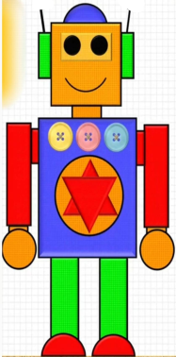

1) How many circle are there in the above figure ?
2) Give 1 real life example of triangle .
3) How many line of symmetry are there in rectangle ?
4) Name a shape whose opposite sides are equal .
5) Count the number of rectangle in the above figure .

